**SCRAP IT OUT**

**A Mini-Project Report**

**Under**

**Implementation of Technology**

***Submitted by***

**Abhishek Roshan B045**

**Akshay Karvir B061**

**Shruti Kadam B052**

**Nishant Soni B055**

***in partial fulfillment for the award of the degree***

***of***

**B.Tech.**

**IN**

**Computer Science**

**at**

**Mukesh patel school of technology management and engineering, vile parle.**

**March 2015**

**CERTIFICATE**

This is to certify that the project entitled **Scrap It Out** is the bonafide work carried out by **Abhishek Roshan, Akshay Karvir, Shruti Kadam, Nishant Soni** B.Tech (Computer Engineering), MPSTME (NMIMS), Mumbai, during the fourth semester of the academic year 2014-2015, in fulfillment of the requirements for the award of the Degree of Bechelors of Technology as per the norms prescribed by NMIMS. The project work has been assessed and found to be satisfactory.

_______________________ ________________________

Examiner 1 Examiner 2

________________________

Dean

Dr. S.Y. Mhaiskar

**DECLARATION**

We, **Abhishek Roshan, Akshay Karvir, Shruti Kadam, Nishant Soni** B.Tech (Computer Engineering), semester- IV, understand that plagiarism is defined as anyone or combination of the following:

1. Un-credited verbatim copying of individual sentences, paragraphs or illustration (such as graphs, diagrams, etc.) from any source, published or unpublished, including the internet.

2. Un-credited improper paraphrasing of pages paragraphs (changing a few words phrases, or rearranging the original sentence order)

3. Credited verbatim copying of a major portion of a paper (or thesis chapter) without clear delineation of who did wrote what.

4. We have made sure that all the ideas, expressions, graphs, diagrams, etc., that are not a result of our work, are properly credited. Long phrases or sentences that had to be used verbatim from published literature have been clearly identified using quotation marks.

5. We affirm that no portion of my work can be considered as plagiarism and we take full responsibility if such a complaint occurs. We understand fully well that the guide of the seminar/ seminar report may not be in a position to check for the possibility of such incidences of plagiarism in this body of work.

Signature of the Students:

___________ ____________ ___________ ____________

Name: ___________ ____________ ___________ ____________

Roll No. ___________ ____________ ___________ ____________

Place: Mumbai

Date: April 2015

Table of Content

Sr. No. Topic Page No.

List of Figures i

List of Table ii

Abbreviation iii

Abstract iv

# 1. Introduction 1

## 1.1 Problem Specification 2 and so on..

## 1.2 Solution Outline

## 1.3 Application/Usage

# 2. System Analysis

## 2.1 Existing System (If any)

## 2.2 Software Requirement

## 2.3 Hardware Requirement

# 3. Design and Methodology

## 3.1 Flowchart of App

## 3.2 Output (Screenshot of the app)

## 3.3 Limitation of App

# 4. Conclusion and Future Scope

# 5. References

1. **INTRODUCTION**

As a student we might not be aware of most of the things that are happening in our society. People are now becoming more reliable on electronic gadgets than any other thing in particular. If we have to pay bills, we pay our bills online now rather than going to the bill paying section and pay. We all know paying bills online is pretty easy and safe now. So if we are doing so many things on internet now and making an app for it too, why not do the same for smaller things too? At grass root level. Our vision is that from now on people sitting at home watching TV will never have to browse internet to get *raddiwala’s* phone number around them or go out and find one. With this app you just have to click a pic and press SEND and our representatives will send you our employee in the next 48 hrs to buy your *raddi* in a safe and secure way.

* 1. **Problem Specification**

Consider an example, a guy name Prakhar Goyal has accumulated 8 Kgs of *raddi* and he wants to sell it to a *raddiwala*. He has just moved to Mumbai and he doesn’t know much about the place or people. Now what will he do? As he is new, the first thing he will do is he will ask his neighbors regarding any *raddiwala’s* phone number. Then he will call the *raddiwala* and will have to wait for him to come and collect the scrap at very low price.

* 1. **Solution Outline**

Now suppose Prakhar gets a hold of our app SCRAP IT OUT. Now he will open the app and click a picture of the scrap material and press SEND. We will receive his details and we will convey him that we will collect his scrap material within next 48 Hrs at very reasonable price.

* 1. **Application Usage**

In this app we will provide a very new feature called “SNAP-N-SCRAP” which is basically a very convenient feature for a user.

In this, he doesn’t have to fill out the details of the kind of waste he wants to scrap and the amount of scrap he wants to discard, he simply has to click a picture and send it to us. Our person will accordingly come and collect the scrap.

Other way of using this app is that once the user logs in on our app, he will have to mention what kind of scrap he wants to sell out, for example; glass, paper, metal etc. Then he will mention the amount of waste. The next layout would be displaying the current rate of various scrap materials and the rate which we will provide.

1. **SYSTEM ANALYSIS:**
   1. **Existing System**

There is already an existing app called “RADDIWALA”

Description

BharatNirman Group of Youngsters – Is a social organization and started their first initiative as Raddiwala. They have developed an Android Application – “Raddiwala”.

Wherein they collect waste papers (Raddi) from the customer’s doorstep, within 48 hours after their registration on this android application.

Features of Raddiwala Android Application -

1] User friendly interface

2] Requires very less memory, so easy to download

3] Both options, SMS and E-mail are provided for registration

4] Confirmation of registration is conveyed to the customer

Customer satisfaction is our main priority -

1] We are using Standard Digital Weighing Machine.

2] The frequent users are provided free coupons for various services such as food, education, etc..

We, also contribute to the society from whatever profit we earn from this initiative such as -

1] We are planning to start free insurance scheme for our staff which mainly comprises of financially backward people

2] Free Distribution of Career Guidance Book for financially backward students

**.**

* 1. **SOFTWARE REQUIREMENT**

We are building our app on android platform. All android devices above android 4.0.3 can run our app on their phones.

We are using:

* Wamp server to store our database.
* Android studio for building app.
  1. **HARDWARE REQUIREMENT**
* App requires 2 Mb of space.
* App requires 35 Mb of RAM to run.
* App will run on all android phones, tablets and pc

1. **Design and Methodology** 
   1. **Flowchart of app:-**

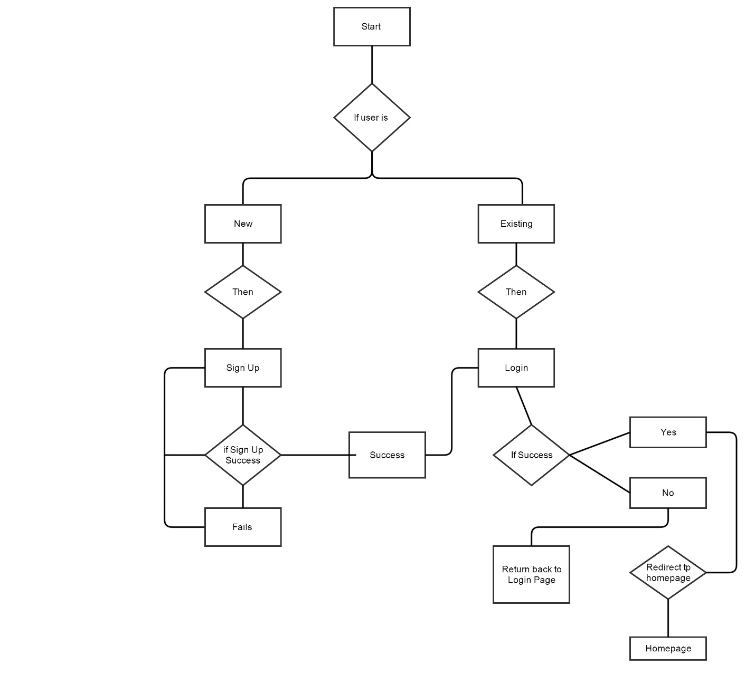

* 1. **OUTPUT SCREENSHOT**

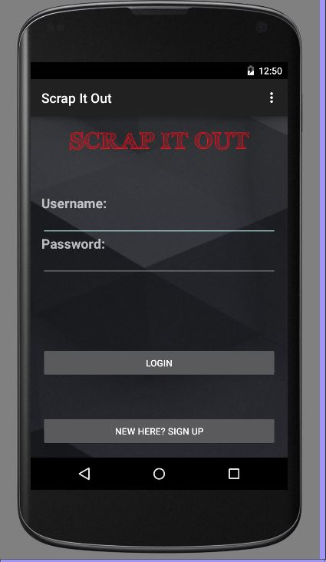

**Login Screen** (fig 1.1)

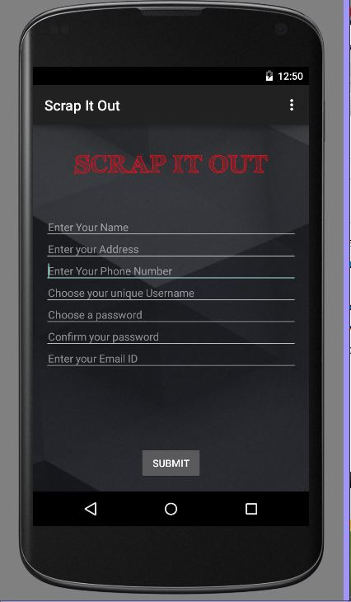

**Registration Page.** (fig 1.2)

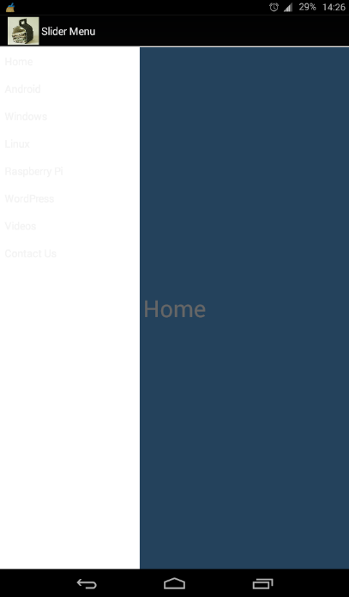

**Homepage** (fig 1.3)

*Has navigation drawer.*

* 1. **Limitation of App**

Our app is presently limited to android users. If our app is a success on android platform we will be launching our app for apple devices.

As our app is on the beta phase, we are limiting our app’s reach to Vile Parle only. If it’s a success we will increase the reach of our app.

1. **CONCLUSION AND FUTURE SCOPE**

Our app is towards completion and also our app requires ground-work.

Once the app is complete it will be easy for the people to use it since it is a very user-friendly app and also easily available. The customer doesn’t have to wait for really long to dispose of his waste and it will take less efforts.

People will prefer our app because we will provide a rate higher than the market rate for per kg. Also we are reducing the middle-men commission which basically helps increase the GDP. It’s a very economical app and better than the existing “raddiwala” app.

Since we have this all new feature “SNAP-N-SCRAP”, it differentiates us from the existing app. We have possibly tried to make the most user-friendly app.

In future we expand our app’s reach to whole country as till now our app’s reach is limited to only one city “Vile Parle”.

1. **REFERENCE**

Our dear ma’am has been very supportive to us at all times. She has helped us to understand and implement our ideas towards app development.

There was self-learning always.

We understood the importance of working under one single team.

Sites we referred:

* <https://developer.android.com/training/basics/firstapp/index.html>
* <https://www.udacity.com/course/ud853>